**Neha Maddali**

**Question 1:**

Contingency table:

Proportions:

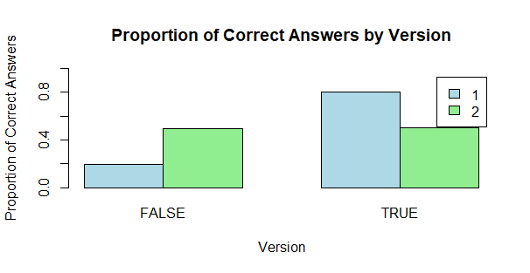

H0: There is no difference in the proportions of incorrect answers between Version 1 and Version 2 of the question among STAT 101 students.

Ha: There is a difference in the proportions of incorrect answers between Version 1 and Version 2 of the question among STAT 101 students.

Test statistic: 58.961

P-value: 1.608e-14

There is strong evidence to suggest that there is a difference in the proportions of incorrect answers between Version 1 and Version 2 of the question among STAT 101 students.

The 95% confidence interval for the difference in proportions of incorrect answers between the two versions doesn’t include zero, further supporting the conclusion of a significant difference.

**Question 2:**

Contingency Table:



Proportions:

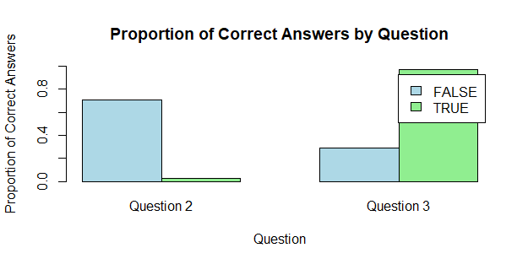

H0: the proportion of students who correctly identified the horizontal axis of the histogram is equal to the proportion of students who correctly identified the vertical axis of the histogram

Ha­: the proportion of students who correctly identified the horizontal axis of the histogram is different from the proportion of students who correctly identified the vertical axis of the histogram.

Test statistic: 313.47

P-value: <2.2e-16

There is strong evidence to suggest that there is a difference in the proportion of students who correctly identified the horizontal axis of the histogram and the proportion of students who correctly identified the vertical axis of the histogram.

The 95% confidence interval for the difference in proportions of correct answers between identifying the horizontal and vertical axes doesn’t include zero, further supporting the conclusion of a significant difference.